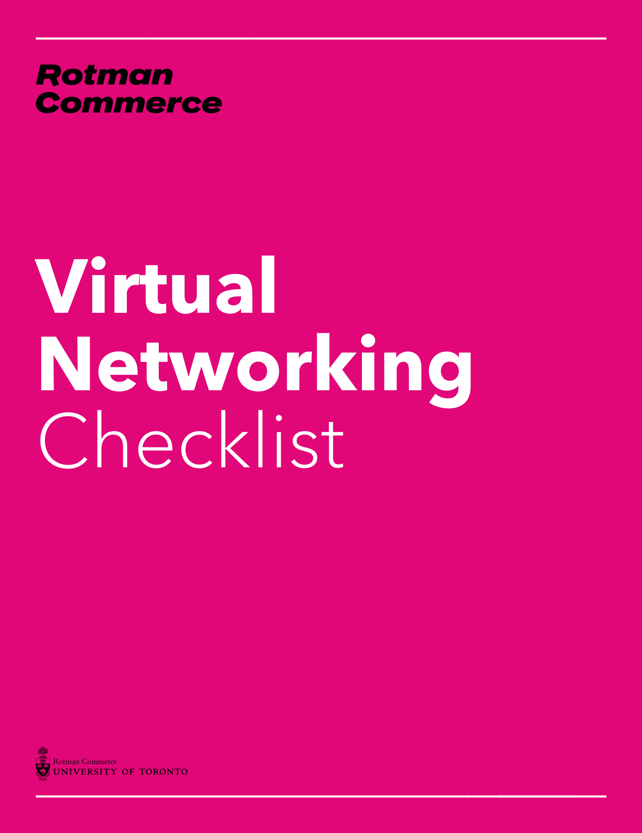
Virtual Networking
Skills checklist

Where I need help to improve my networking results…

☐ | Knowing what to do when entering a networking event
☐ | Reducing stress when first meeting a new person
☐ | Having more options to start conversations
☐ | Having the ability to easily remember names
☐ | Learning how to make others feel comfortable more quickly
☐ | Discovering more ways to demonstrate interest in others
☐ | Being able to more quickly develop rapport with others
☐ | Improving my listening skills
☐ | Using questions more effectively to get additional information
☐ | Strategies to get others to want to know more about me
☐ | Having the ability to leave conversations
☐ | Communicating more effectively about myself and what I do
☐ | Improving my handshake and eye contact
☐ | Finding ways to stay in touch
☐ | Turning networking conversations into additional opportunities
☐ | Creating an online network
☐ | Having the ability to measure my networking results
☐ | Having a clearer idea of who I should network with
☐ | Knowing better how and when to follow up
☐ | Finding effective networking activities
☐ | Asking for introductions
☐ | Learning to relax and feel less stressed
☐ | Knowing topics that are taboo to discuss
☐ | Demonstrating confidence on and offline
☐ | Other:

